Motiff: AI Powered Professional interface Design tool

Motiff is the design tool for the AI era to get powerful Al and comprehensive design features, prototyping, Dev Mode, and an all-in-one platform.

The AI menu option in the top navigation bar of the tool – facilitates the user to generate AI powered UI based on the topics entered.

Following are the topics that I entered were along with the UI output:
- Full Stack UX Professional
- Sr. UX Designer with Bank of America

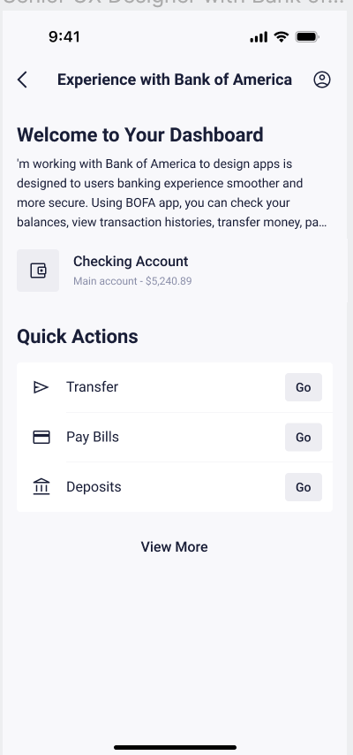

Did it deliver on your needs?

Yes, the UI generated by the tool solved 70% of my base work and required some work to achive what I needed. Rest I need not to out too much of my time just to create the basic layout and backgrounds of what I needed. The work involved more of modifications to the existing frames.

Did you have to work with the tool multiple times?
The UI frames generated by the tool did not required to work multiple times.

Would you consider the output “ready for presentation”?

The output generated by the Motiff AI was ready up to 70% for the presentation.

What did it not do well?
This tool is lacking behind with the capability of adding any images of your own. Also, some the sub-menu options under the AI menu were not clear and seems to be redundant, such as AI Design System Creator and AI magic Box.

Would you employ this tool in an actual project?

Yes, I would love to explore the AI technology of Motiff tool with my actual project and would like to see – how it would take my designs to the next level.

