Grammarly

Grammarly uses AI to make writing experience convenient. It provides personalized AI guidance and text generation on any app or website. It reviews spelling, grammar, punctuation, clarity, engagement, and delivery mistakes in English texts, detects plagiarism, and suggests replacements for the identified errors. It also allows users to customize their style, tone, and context-specific language.

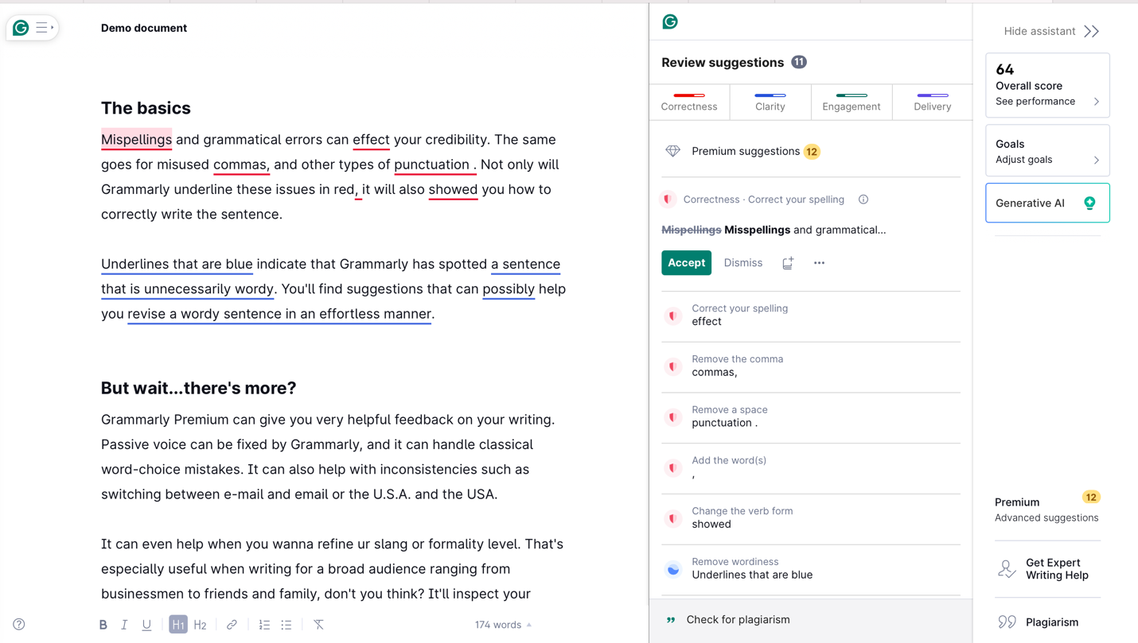

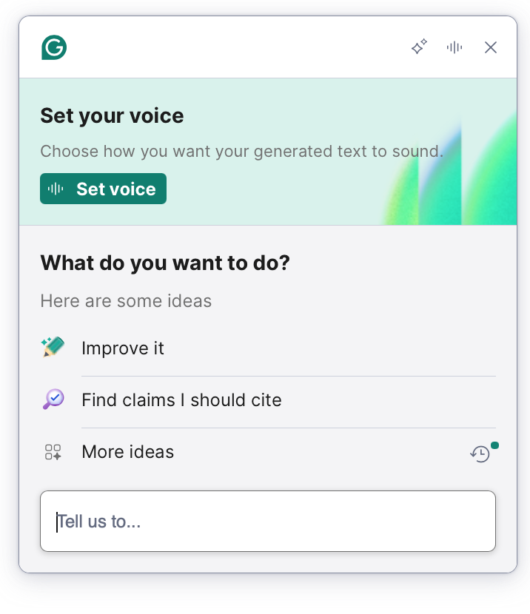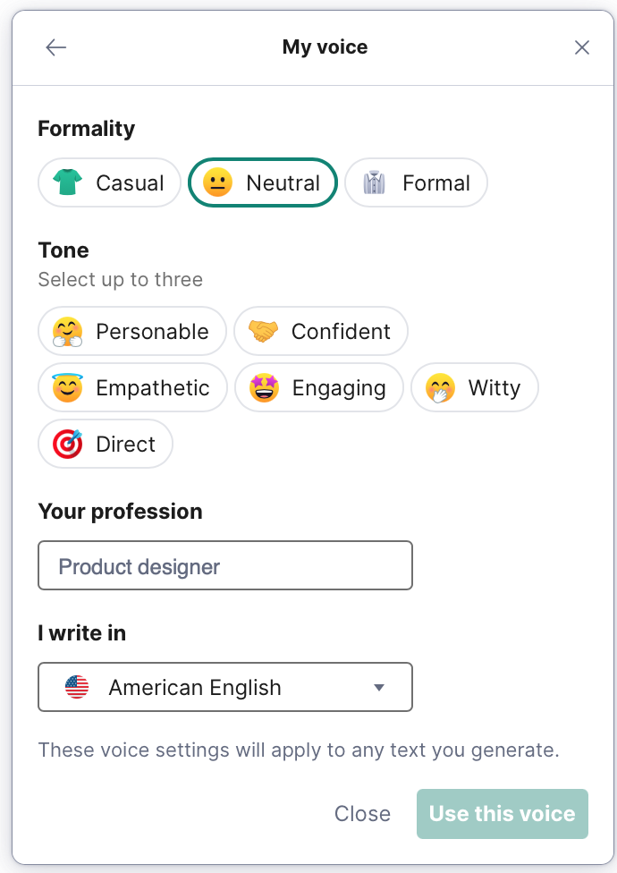

Grammarly use generative AI – when installed, checks English language anywhere you type in your system or phone. The AI technology used here, helps you to brainstorm and even helps to write the first draft version. The Machine Learning (ML) data stores thousands of words, grammar, and punctuations to review and identify errors in your document. In addition, ML algorithms compare billions of web pages to your document to check-out plagiarism.

The data used within machine learning algorithms helps to identify the slang, tone and formality level in your documents. It'll also inspect your vocabulary carefully and suggest the best word to make sure you don't have to analyze your writing too much. ML also helps to fix passive voice, along with handling of classical word-choice mistakes.

The generative AI in Grammarly allows to generate sounds to your text and can even set the formality, tones, type of English to your sounds.

User Interaction > Checkout spellings, grammar, and punctuation > Plagiarized data > Set tone and formality level > Can use where you type in your system > Provide personalized writing experience > Brainstorming your ideas – like human interaction

