Popai Generative AI

PopAi masterfully generates images on command, provides access to image prompts and generation codes, and offers image-based homework help, enriching educational support with visual aids.

I explored Popai to create presentation about the “Challenges of Parents in managing their kids after school activites.” But you must be thinking – ChaptGPT provides the similar functionality – the it’s different from it. ChatGPT facilitates conversational AI capabilities and vast knowledge base.
While PopAi focuses on data-driven insights and personalized content generation with an emphasis on visual appeal. When typed-in just the title “Challenges in Managing the after-school activities.” The generative AI itself assumes that the presentation needs to be created for the parental challenges and created slides thinking from the perspective of a parent.

This tool is great for the people -whose demands creating presentations on regular basis and they spend a big time of the day to create one.

Please find the attached screenshots below

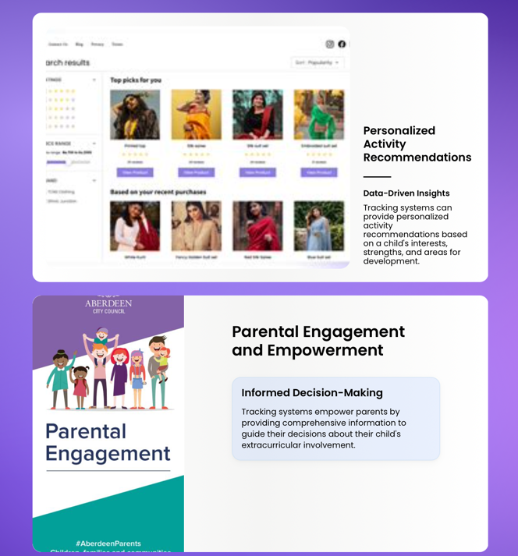

What Complex Algorithm Popai used:

As per my understanding and observation – popai used supervised learning algorithm. Popai used a training set to yield the desired output.
Popai used two types of problems when data mining—classification and regression:
- Classification uses an algorithm to accurately assign data into specific categories. It recognizes specific topics within the dataset and create visual presentations that are well labeled and defined.

- Regression is used to understand the relationship between dependent and independent variables. In this scenario using regression algorithm – popai identified between the topic, “Challenges in managing after school activities: and the target audience, that is, parents, and created visual presentation understanding the need of target audiences. It also provided statistical data to the parents to support the content in the presentation.

Also, I tried to do some coding on the same topic, ““Challenges of Parents in managing
their kids after school activities.” Using Popai FullStack feature, and the result was quite astonishing than what I expected. Please refer to the result below:

